Advanced IT courses in the medical field accredited in the European Union
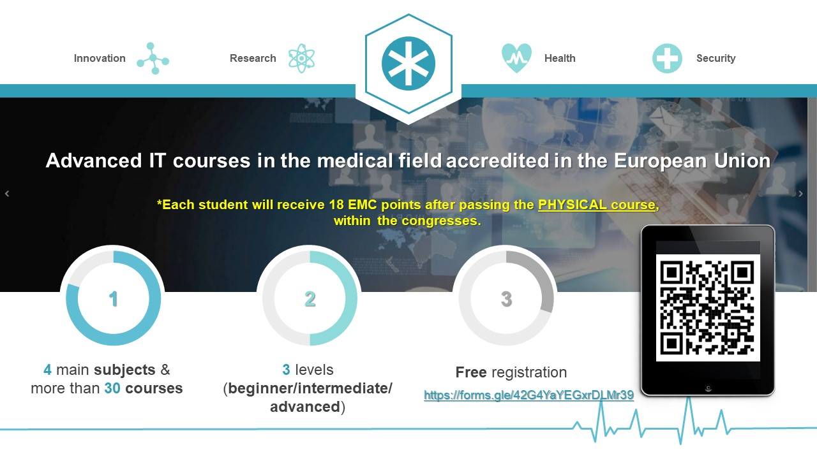

Representatives of the DIGI4ME project - Health sector skill alliance for creating innovative and efficient VET programmes and improving the digital Skills of medical physics and health professionals, teaching staff and researchers from the Politehnica University of Bucharest (UPB), participated during November 11-13 at the medical congress Quo Vadis, Dermatology-venerology Bridge over time, a new beginning, held in Bucharest.
The project team presented the participants with the complete list and curriculum of the courses that will be developed within the project and will be intended for medical professionals, with the aim of improving their IT skills.
The courses are accredited in the European Union and will take place physically and online. The registration is free, through the following registration form:
https://forms.gle/42G4YaYEGxrDLMr39. The courses will be created on 3 levels of learning, beginner/intermediate/advanced, to best meet the training needs of professionals. Participants in the physical courses, within the medical congresses, will receive 18 EMC points after passing each course.
The Polytechnic University of Bucharest (UPB) will develop four advanced courses:
- 3D modeling and printing (3D-DT3)
- Introduction to Healthcare Data Science (I-HDS1)
- Health informatics (HI-HDS2)
- Database management (DM-HDS3)
and a course in partnership with the University of Patras (Greece): "Database Management - Big Data".
The educational material and courses will be freely available as online educational resources (OER) in the VOOC web system, and interested users can evaluate them and enroll in the courses. The certification scheme is formulated by UNICERT, expert in accreditation and certification procedures in VET – vocational educational training.

About the project
The main aim of the DIGI4ME project is to address the skills gap in the healthcare workforce and provide an innovative training framework together with a certification scheme. The project will address the first 4 CEC levels. It will formulate a wide range of courses to improve the skills of health professionals. New programs will be formulated to address cutting-edge methods and content in the health sector.

Project manager:
Conf.dr. Dorina Popovici

http://www.digi4me.eu
www.twitter.com/digi4me1
www.facebook.com/digi4me
www.instagram.com/digi4me.eu
www.linkedin.com/in/digi4me-project-60222120a

